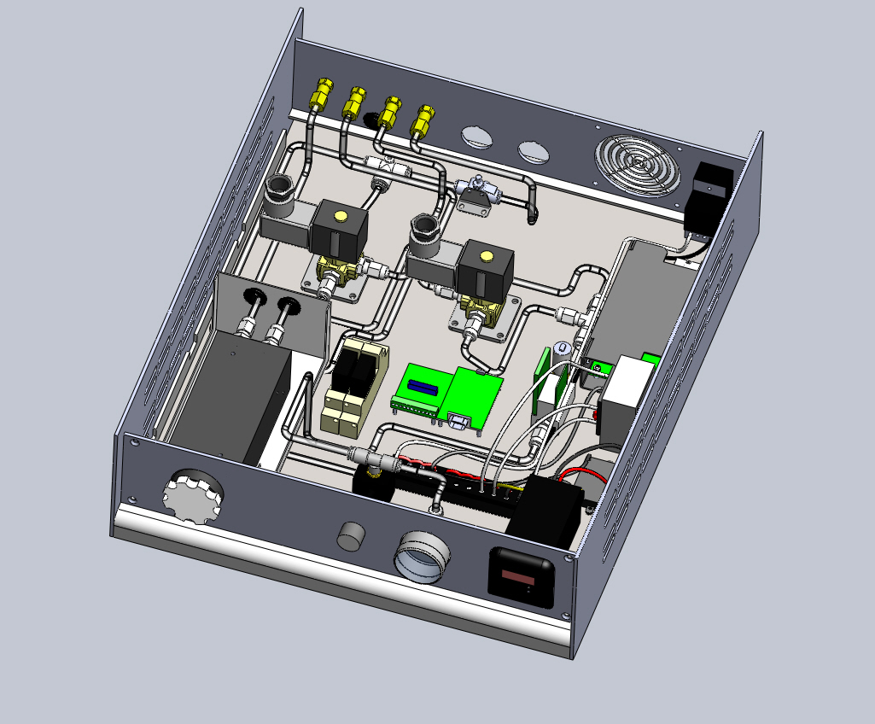


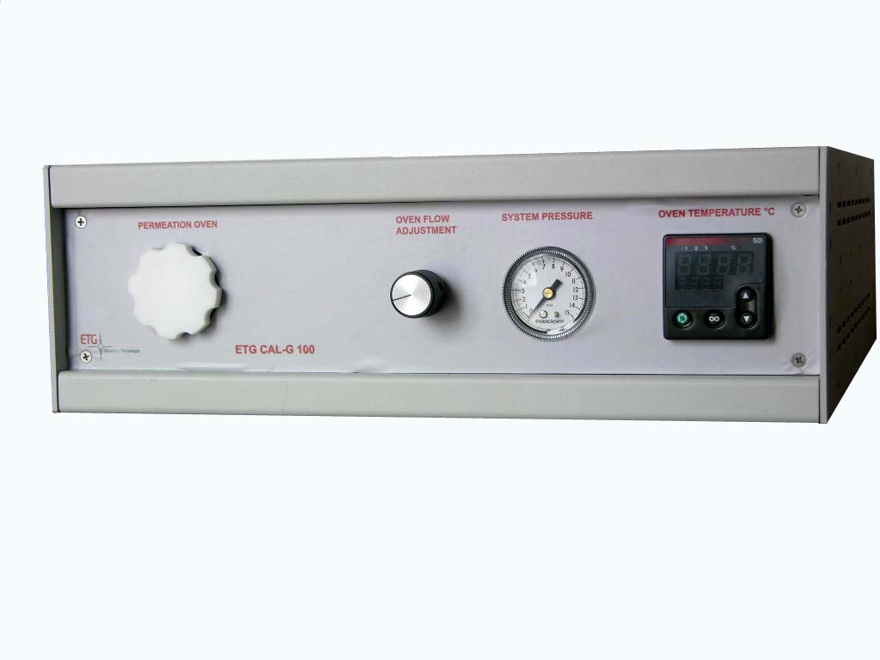
Home Page
Product Overview
Contact / Links / Partners
< Back to Product List
A reliable partner in gas analysis & monitoring
ETG Risorse e Tecnologia
CALG-100
Permeation Calibrator
The calibrator ETG CALG100 has been designed to provide a high level of calibration for the use of analyzers HC and BTX (ppb level). The use of the calibrator is very simple, thanks to the high automation of its components. In addition, the instrument is equipped with two USB ports which can be controlled directly from a PC connected to it the solenoid calibration (zero and span) and the direct flow to the oven, that needs to set the value of the gas dilution (controlled by a MFC). On the front panel you can set a temperature value that will remain stable over time. The calibrator is mounted in a drawer rack size 3U. The calibrator includes a computerized management software for its.

The calibrator is equipped with two solenoid calibration: zero and span. using software supplied with, the user can, depending on the setting you must set (to use the software refer to the section of the manual) to activate one or the other solenoid. If, for example, we are conducting a span calibration, after setting the desired value, the system (by a formula) will instruct the MFC flow to be applied.

Once inserted into the permeation tube oven, and set its operating temperature, the system, for example, if you are calibrating the span, will set a value stream that will serve to dilute the gas calculated from the concentration desired that the user has entered in the software. In the meantime, checks will be performed by a system that maintains the temperature and pressure. all other components (such as relays, switches, transformers, etc ...) are only the automation of the instrument.
Microprocessor-based temperature controller
featuring proportional heater control and digital
display of set point and oven temperatures

Precision dilution and optimal flow
thanks to Mass Flow Controller

Electrovalves for automatic selection of
Zero/Span/Sample

Software available

Digital display of temperature and set point

PT100 temperature sensor

Front panel mounted pressure regulator,
pressure guage, temperature controller
and oven inlet

Operating Range:
1 deg. C above ambient to 60 deg. C,

Unit Operating Temperature:
5 deg. C to 45 deg. C

Warm Up:
Less than 30 minutes

230 VAC, 50/60 Hz

Unit Size 5.25” (13.3 cm) x 19”
(48.3 cm) W x 15” (38.1cm) D

Weight 18 lbs (8.2 kg)

Rack Mount Kit 3U

Weight 18 lbs (8.2 kg)

